Letter Template if School Administrator is Informed of a Confirmed Case of COVID-19 by Staff or Parent AND if there is a delay in the school medical officer notifying the school.

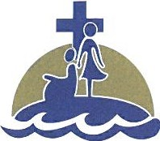
Catholic Independent Schools

Of the Diocese of Victoria
1-4044 Nelthorpe Street, Victoria, BC V8X 2A1
Phone: (250) 727-6893 Fax: (250) 479-5423

Insert Date

Dear Parents/Guardians,

We have been made aware from a member of our school community that they or their child has tested positive for COVID-19. They are self-isolating at home with support from local public health teams. We are waiting to connect with Island Health Authority to address this situation.

We will support Island Health Authority as they undertake contract tracing to determine if any other members of our school community were in contact with the person who tested positive for COVID-19, and if any additional steps are required. We are following the protocol established for these circumstances:
- The health authority will perform contact tracing;
- The health authority will determine if anyone in the school community was in contact with the person who tested positive for COVID-19 while they were potentially infectious;
- The health authority will determine if anyone in the school community is a close contact that is required to self-isolate.

Only the health authority can determine who is a close contact.
- If you are contacted by Island Health Authority, please follow their advice.
- If you are not contacted by Island Health Authority, it has been determined that your child is not at risk of developing COVID-19.
- To ensure personal privacy rights are maintained, we cannot provide additional details.

Students should continue to come to school while contact tracing is underway. Please continue daily health checks to monitor your child for illness. If you have symptoms of COVID-19, please stay home, call 8-1-1, and follow the guidance from the BC Centre for Disease Control.

We ask for your patience, and we will work closely with Island Health to provide on-going communication as required. The safety and well-being of our students, families and staff remains our highest priority.

Please be reassured that our school will continue to implement the strict health & safety protocols/procedures we have in place so that children can continue to attend school as safely as possible.
As we have a close-knit school community, we would ask you to please refrain from sharing any information about the situation on social media or within your personal network. Please know that official communication from the School will come as quickly and transparently as regulations permit.
We ask during this time, that all members of the school community show compassion and empathy toward each other.

Together in hope,
Beverly Pulyk
Superintendent

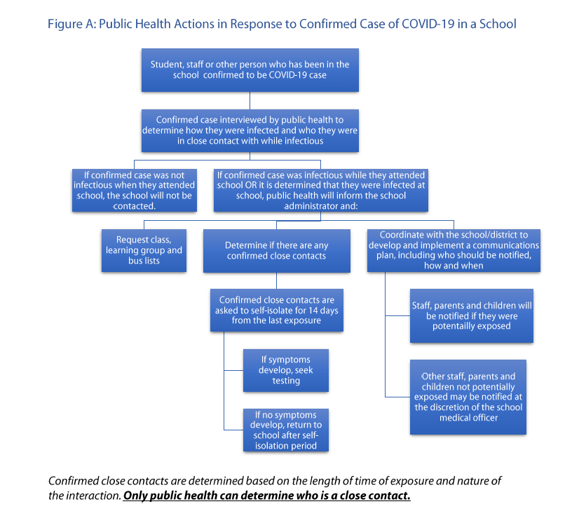

Letter Template if School Administrator is Informed by the Local Health Authority if a Confirmed Case of COVID-19 exists in the School

Catholic Independent Schools

Of the Diocese of Victoria
1-4044 Nelthorpe Street, Victoria, BC V8X 2A1
Phone: (250) 727-6893 Fax: (250) 479-5423

Insert Date

Dear Parents/Guardians,

The Local Health Authority has made us aware that a member of our school community has tested positive for COVID-19. They are self-isolating at home with support from local public health teams.

We are supporting Island Health Authority as they undertake contract tracing to determine if any other members of our school community were in contact with the person who tested positive for COVID-19, and if any additional steps are required. We are following the protocol established for these circumstances:
- The health authority is performing contact tracing;
- The health authority will determine if anyone in the school community was in contact with the person who tested positive for COVID-19 while they were potentially infectious;
- The health authority will determine if anyone in the school community is a close contact that is required to self-isolate.

Only the health authority can determine who is a close contact.
- If you are contacted by Island Health Authority, please follow their advice.
- If you are not contacted by Island Health Authority, it has been determined that your child is not at risk of developing COVID-19.
- To ensure personal privacy rights are maintained, we cannot provide additional details.

Students should continue to come to school while contact tracing is underway. Please continue daily health checks to monitor your child for illness. If you have symptoms of COVID-19, please stay home, call 8-1-1, and follow the guidance from the BC Centre for Disease Control.

We ask for your patience, and we will work closely with Island Health to provide on-going communication as required. The safety and well-being of our students, families and staff remains our highest priority.

Please be reassured that our school will continue to implement the strict health & safety protocols/procedures we have in place so that children can continue to attend school as safely as possible.
As we have a close-knit school community, we would ask you to please refrain from sharing any information about the situation on social media or within your personal network. Please know that official communication from the School will come as quickly and transparently as regulations permit.
We ask during this time, that all members of the school community show compassion and empathy toward each other.

Together in hope,
Beverly Pulyk
Superintendent

Letter Template if there is a Rumour of COVID-19 Case circulating in the School Community.

Catholic Independent Schools

Of the Diocese of Victoria
1-4044 Nelthorpe Street, Victoria, BC V8X 2A1
Phone: (250) 727-6893 Fax: (250) 479-5423

Insert Date

Dear Parents/Guardians,

We have recently been made aware of concerns regarding the rumoured presence of COVID-19 in our school community.

At this time, we have not been notified by the Local Health Authority regarding any student or staff being confirmed to have COVID-19.

If any member of the school community were to test positive for COVID-19, we will support Island Health Authority as they undertake contract tracing to determine if any other members of our school community were in contact with the person who tested positive for COVID-19, and if any additional steps were required.

Only the health authority can determine who is a close contact.

Students should continue to come to school. Please continue daily health checks to monitor your child for illness. If you have symptoms of COVID-19, please stay home, call 8-1-1, and follow the guidance from the BC Centre for Disease Control.

We ask for your patience, and we will work closely with Island Health to provide on-going communication as required. The safety and well-being of our students, families and staff remains our highest priority.

Please be reassured that our school will continue to implement the strict health & safety protocols/procedures we have in place so that children can continue to attend school as safely as possible.
As we have a close-knit school community, we would ask you to please refrain from sharing any information about the situation on social media or within your personal network. Please know that official communication from the School will come as quickly and transparently as regulations permit.
We ask during this time, that all members of the school community show compassion and empathy toward each other.

Together in hope,
Beverly Pulyk
Superintendent

